Project Design Phase-II

Data Flow Diagram & User Stories
Date Team ID
Project Name

Maximum Marks
15 February 2026
LTVIP2026TMIDS24941
ToyCraft Tales: Tableau's Vision into Toy Manufacturer Data
4 Marks

Data Flow Diagrams:
A Data Flow Diagram (DFD) is a traditional visual representation of the information flows within a system. A neat and clear DFD can depict the right amount of the system requirement graphically. It shows how data enters and leaves the system, what changes the information, and where data is stored.
Example: DFD Level 0 (Industry Standard)

Example: (Simplified)
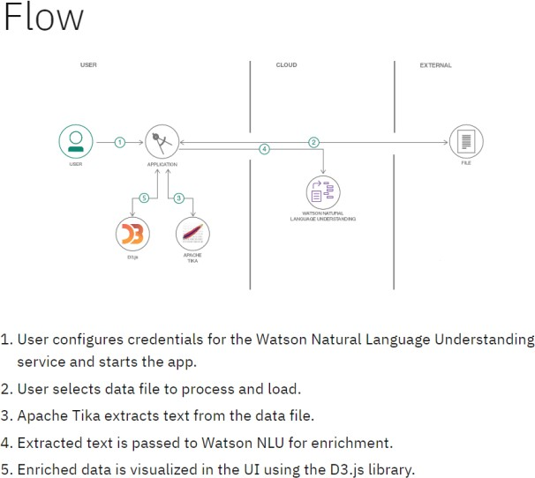
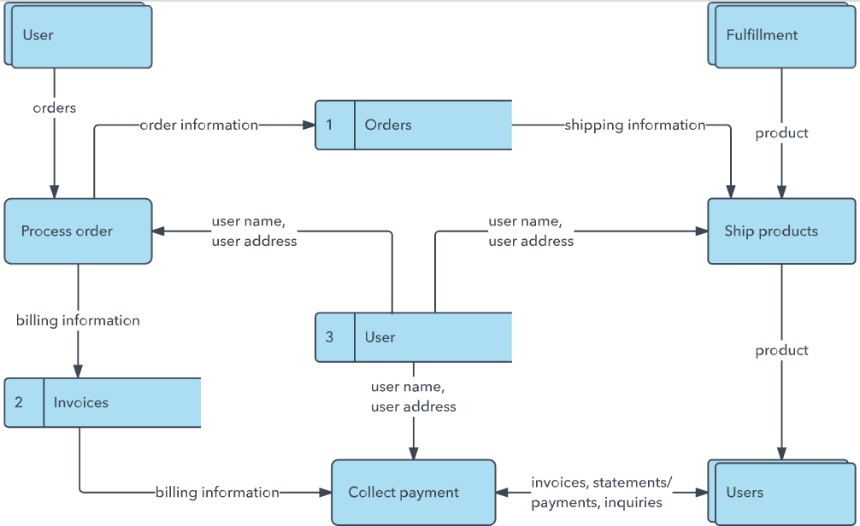

User Stories
Use the below template to list all the user stories for the product.

User Type | Functional  Requirement (Epic) | User Story Number | User Story / Task | Acceptance criteria | Priority | Release
Customer (Mobile user) | Registration | USN-1 | As a user, I can register for the application by entering my email, password, and confirming my password. | I can access my account / dashboard | High | Sprint-1
 |  | USN-2 | As a user, I will receive confirmation email once I have registered for the application | I can receive confirmation email & click confirm | High | Sprint-1
 |  | USN-3 | As a user, I can register for the application through Facebook | I can register & access the dashboard with Facebook Login | Low | Sprint-2
 |  | USN-4 | As a user, I can register for the application through Gmail |  | Medium | Sprint-1
 | Login | USN-5 | As a user, I can log into the application by entering email & password |  | High | Sprint-1
 | Dashboard
Customer (Web user) | Dashboard Interaction | USN-6 | As a user, I can filter toy data by region and category to explore trends. | Filtered data updates  graphs and maps correctly. | High | Sprint-1
Customer (Web user) | Survey Participation | USN-7 | As a user, I can submit a toy preference survey | Survey data is successfully submitted and reflected in summary charts. | Medium | Sprint-2
Customer Care Executive | View Reports | USN-8 | As a care executive, I can view toy performanc | e I can generate reports  toy type. | High | Sprint-2
Customer Care Executive | Access Feedback | USN-9 | As a care executive, I can view survey feedback to identify popular toys. | I can see ranked results from submitted surveys. | Medium | Sprint-3
Administrator | Data Management | USN-10 | As an admin, I can upload and update toy sales datasets. | Updated data reflects accurately in the dashboard. | High | Sprint-1
Administrator | User Access Management | USN-11 | As an admin, I can approve or block user registrations. | Admin panel shows user status and allows changes. | Medium | Sprint-2

